INNOVA JUNIOR COLLEGE
JC 2 PRELIMINARY EXAMINATION 2
in preparation for General Certificate of Education Advanced Level
Higher 2

CANDIDATE
NAME

CLASS INDEX NUMBER

CHEMISTRY  Paper 3 Free Response  Candidates answer on separate paper.  Additional Materials: Writing Papers  Data booklet | 9647/03, 9746/03  13 September 2010  2 hours

READ THESE INSTRUCTIONS FIRST

Write your name and class on all the work you hand in.
Write in dark blue or black pen on both sides of the paper.
You may use a soft pencil for any diagrams, graphs or rough working.
Do not use staples, paper clips, highlighters, glue or correction fluid.

Answer 4 out of 5 questions.
Begin each answer on a fresh sheet of paper.

You are advised to show all working in calculations.
You are reminded of the need for good English and clear presentation in your answers.
You are reminded of the need for good handwriting.
Your final answers should be in 3 significant figures.

At the end of the examination, fasten all your work securely together.
The number of marks is given in the brackets [ ] at the end of each question or part question.

This document consists of 14 printed pages.
 | Innova Junior College | [Turn over

Answer 4 out of 5 questions.

1 | (a) | The mercury(II) oxide/ Zn metal cell shown below is used in certain scientific instruments. The standard reduction potentials for the two half equations in this cell are as follows:  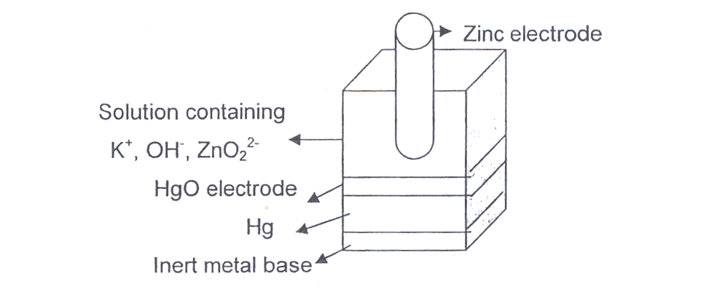
   | Eº/ V
  HgO + H₂O + 2e Hg + 2OH⁻ | +0.10
  ZnO₂²⁻ + 2H₂O + 2e Zn + 4OH⁻ | –1.22
 |  | (i) | Give the half equation for each electrode reaction and hence write an overall balanced equation for the chemical reaction that occurs in the cell during discharge.
 |  | (ii) | Find the e.m.f of the cell. (Assume that the concentration of both OH⁻ and ZnO₂²⁻ in the cell are 1 mol dm⁻³).
 |  | (iii) | In which direction will the electrons flow in the external circuit during discharge?
 |  | (iv) | If the cell is required to provide a continuous current of 0.1 mA for 10 weeks during its useful life, calculate the minimum mass of the HgO that would have to be present initially.
 |  |  | [7]

 | (b) | Compound A can be produced from benzaldehyde by the following reaction scheme:  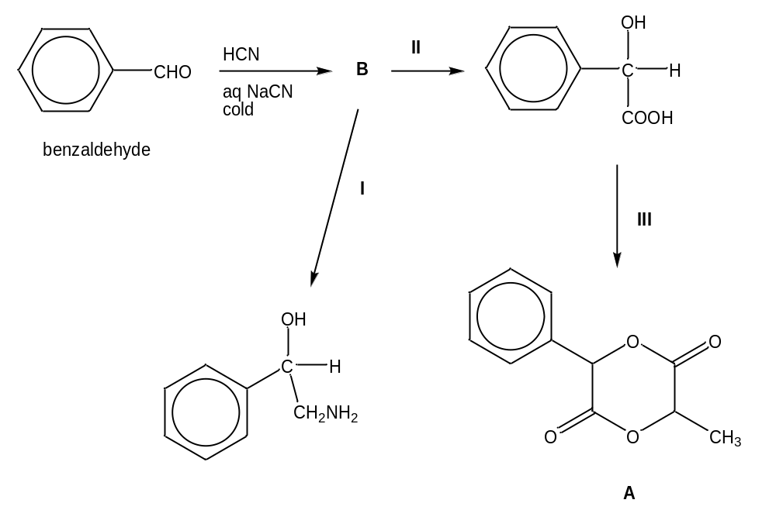
 |  | (i) | Draw the structure of B.
 |  | (ii) | State the type of reaction for reaction III.
 |  | (iii) | Suggest reagents and conditions required for reactions I, II and III.
 |  | (iv) | State the roles of HCN and NaCN in the reaction of benzaldehyde to form B.
 |  | (v) | Suggest why propanal, CH₃CH₂CHO, reacts with HCN at a faster rate than benzaldehyde.
 |  | (vi) | Explain why benzaldehyde has a higher boiling point than propanal.
 |  |  | [10]
 | (c) | Silk from silkworms, used as a fabric shows a different secondary structure compared to that produced by spiders.
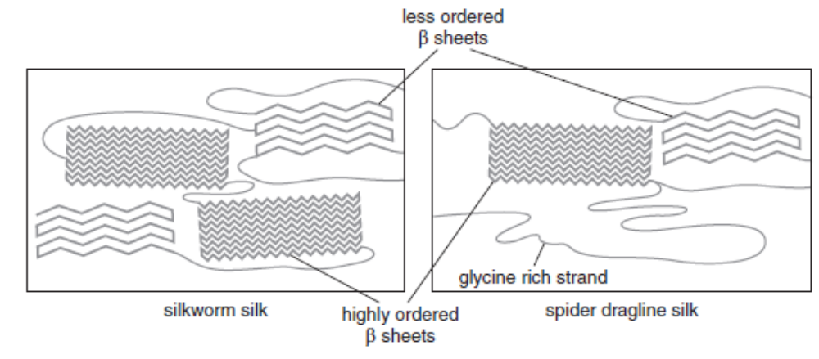
Less ordered sheet

Glycine rich strand

Spider Dragline silk

Silkworm silk
Highly ordered sheet

 |  | (i) | State the type of forces between the sheets.
 |  | (ii) | Suggest and explain how these forms of silk could be different in terms of elasticity or water absorption.
 |  |  | [3]
 |  |  | [Total: 20]

2 | (a) | The compound, 2-bromoethylbenzene is often used as a starting material for the production of various fragrances. It forms 2-hydroxyethylbenzene by heating with aqueous sodium hydroxide.  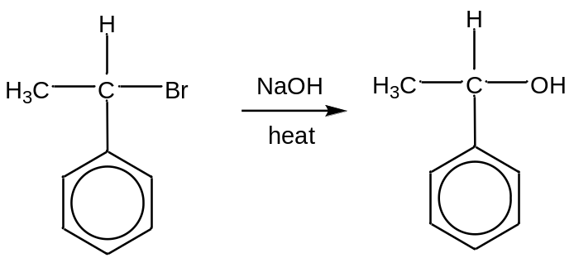
 |  | Name and describe the two possible mechanisms for the above reaction.
 |  |  | [6]
 | (b) | Compound C is a diol commonly used in perfumes. It is also a useful intermediate for the synthesis of other organic compounds as illustrated by the following scheme.  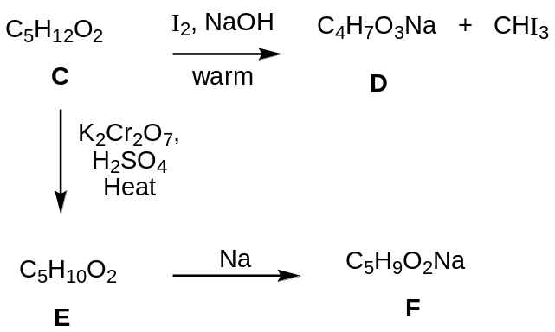
 |  | Given that compound C contains a tertiary alcohol, suggest structures for compounds C, D, E and F. Explanation is not required for this question.
 |  | [4]
 | (c) | In the chemical industry, methane is the feedstock of choice for the production of other chemicals. Methane is reacted with steam at high temperature to form synthetic gas, a mixture of carbon monoxide and hydrogen.  CH₄(g) + H₂O(g) 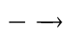 CO(g) + 3H₂(g)
 |  | (i) | An approximate value of ΔH^{θ} can be calculated using bond energy values. Taking the bond energy for the C≡O bond in carbon monoxide to be 1077 kJ mol⁻¹, and using other appropriate bond energies given in the Data Booklet, calculate the value of enthalpy change for the production of synthetic gas based on the above equation.
 |  | (ii) | Predict the sign of ΔS^{θ} for production of synthetic gas, showing your reasoning.
 |  | (iii) | Given the magnitude of ΔS^{θ} is 216 J mol⁻¹ K⁻¹. Use this information, together with your answer to part (c)(i) and (ii), determine the temperature for the reaction to be feasible.
 |  | [6]
 | (d) | One of the components of synthetic gas, carbon monoxide is highly toxic to humans. It binds to the Fe²⁺ of haemoglobin and prevents oxygen intake.
 |  | (i) | Explain how carbon monoxide binds to the Fe²⁺ centre of haemoglobin.
 |  | (ii) | Vanabins are oxygen-transport protein found in sea squirts containing vanadium metal. Explain why vanadium binds oxygen, like iron.
 |  | (iii) | The concentration of vanadium found in the blood cells of sea squirts is around 100 mM and each sea squirt has around 300 cm³ of blood. Given that one litre of seawater contains 7.1 μg of vanadium and assuming that the sea squirt is 100 % efficient in absorbing vanadium from seawater, calculate how many kilogram of seawater each sea squirt has to process to achieve this concentration in their blood.
 |  | [1 μg = 1 x 10⁻⁶ g, 1 mM = 1 x 10⁻³ mol dm⁻³, density of sea water = 1.03 kg/ litre]
 |  | [4]
 |  | [Total: 20]

3 | (a) | At a certain temperature, 1.00 mol of PCl₃(g) and 1.50 mol of Cl₂(g) were placed in a 3 dm³ container. The following graph shows the change in the number of moles of PCl₃, Cl₂ and PCl₅. Equilibrium was established after some time.  PCl₃(g) + Cl₂(g) PCl₅(g)  Time  No. of moles  PCl₅  1.5  PCl₃  1  Cl₂  0.7
 |  | (i) | Write an expression of the equilibrium constant, K_{c}, for this system.
 |  | (ii) | State the equilibrium concentration of PCl₃, Cl₂ and PCl₅. Hence calculate the value of the equilibrium constant, K_{c}.
 |  | (iii) | State the effect on K_{c} if 0.1 mol of Cl₂ gas was forced into the container after equilibrium has been established.
 |  | [5]
 | (b) | When aqueous iron(II) sulfate is boiled with an excess of sodium cyanide, a yellow solution and sodium sulfate are produced. Pale yellow crystals can be obtained by evaporation. These crystals contain 30.26 % sodium, 18.42 % iron, 23.68 % carbon and 27.64 % nitrogen by mass.  Acidification of the yellow solution, followed by passing through chlorine, gives a red solution, from which dark red crystals can be obtained by evaporation.
 |  | (i) | Calculate the empirical formula of the yellow crystals that were obtained by evaporation.
 |  | (ii) | Write the balanced equation for the reaction between iron(II) sulfate and sodium cyanide.
 |  | (iii) | State the role of chlorine in this reaction.
 |  | (iv) | Write down the chemical formula of the dark red crystals that were obtained at the end of the reaction.
 |  | (v) | Write a balanced chemical equation for the reaction between the yellow solution and the chlorine gas.
 | [5]
 | (c) | Heavy water or deuterium oxide, D₂O is a distinctly more structured liquid than ordinary water. Replacement of more than one-third of the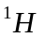by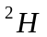in the body fluids of animals by the ingestion of heavy water is lethal. [deuterium, D= 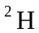]  Deuterium oxide may be used to prepare deuterated compounds.
 |  | (i) | Starting with deuterium oxide, D₂O as the only source of deuterium atoms, suggest how deuterosulfuric(VI) acid, D₂SO₄ can be formed. Write an equation to illustrate the reaction.
 |  | (ii) | Describe what you would observe when D₂SO₄ and NaOD are separately added to solid Al(OH)₃. Write equations with state symbols for the reactions.
 |  |  | [5]
 | (d) | All six elements in Period 3 of the Periodic Table react with oxygen to form the oxides. Describe the reaction, if any, of sodium and sulfur with oxygen. Write equations with state symbols for all the reactions involved.
 |  |  | [3]
 | (e) | Suggest a method by which the following compounds could be distinguished from each other by a chemical test.
 |  | 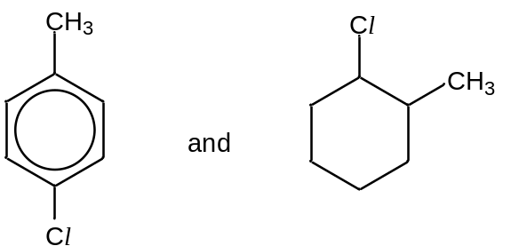
 |  | [2]
 |  |  | [Total: 20]

4 | (a) |  | Glycolic acid (or hydroxyacetic acid) is the smallest α-hydroxy acid (AHA) that can be obtained from sugar cane and unripe grapes. It is used as a chemical peel due to its excellent capability to penetrate skin. |  | 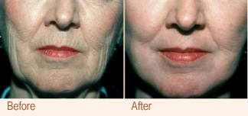
The structure of glycolic acid is shown below.

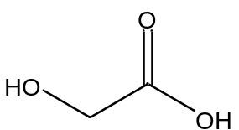

 |  |  | (i) | Carbon, hydrogen and oxygen are the only atoms that make up glycolic acid. Write the electronic configuration of oxygen in the ground state.
 |  |  | (ii) | The first and second ionisation energies of oxygen are 1310 and 3390 kJ mol⁻¹ respectively. Explain why more energy is needed to remove the second electron than the first electron.
 |  |  | (iii) | Although oxygen and sulfur are from the same group in the Periodic Table, sulfur can form SF₂, SF₄ and SF₆ when it reacts with fluorine while oxygen can only form OF₂. Explain why this is so.
 |  |  | (iv) | In 0.05 mol dm⁻³ aqueous solution of glycolic acid, the hydrogen ion concentration is found to be 2.71 x 10⁻³ mol dm⁻³.
I |  | Calculate the pH of the glycolic acid solution.
II |  | Hence, determine the acid dissociation constant for glycolic acid.

 |  | (v) | When glycolic acid is burnt in oxygen, besides carbon dioxide and water vapour, carbon monoxide might also be produced. Explain one detrimental effect of this combustion on the environment or human beings.
 |  |  | [6]
 | (b) | Glycolic acid undergoes reactions with organic alcohols and acids to form esters. Glycolic acid butyl ester (GABE) is a derivative of glycolic acid and it can be used in a number of ways from cosmetics to industrial cleaning.  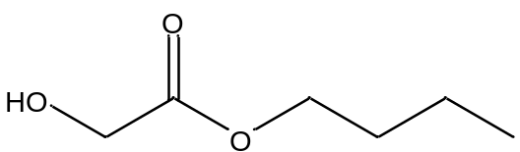  glycolic acid butyl ester (GABE)  The following data is obtained from a kinetic study on the hydrolysis of GABE using aqueous sodium hydroxide.
  Experiment | Initial concentration / mol dm⁻³ |  | Initial rate /  mol dm⁻³ s⁻¹
  Experiment | [GABE] | [NaOH] | Initial rate /  mol dm⁻³ s⁻¹
  1 | 0.001 | 0.005 | 2 x 10⁻⁴
  2 | 0.002 | 0.005 | 4 x 10⁻⁴
  3 | 0.006 | 0.004 | 9.6 x 10⁻⁴
 |  | (i) | Determine the order of reaction with respect to
 |  |  | I | GABE
 |  |  | II | sodium hydroxide
 |  | (ii) | Hence write the rate equation for the hydrolysis of GABE with aqueous sodium hydroxide.

 |  | (iii) | GABE is the starting material in the production of 3-aminopropan-1-ol.  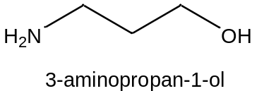  A 3-step synthesis of 3-aminopropan-1-ol from glycolic acid butyl ester (GABE) is shown below. Draw the structure of G and write the reagents and conditions for reactions I to III.
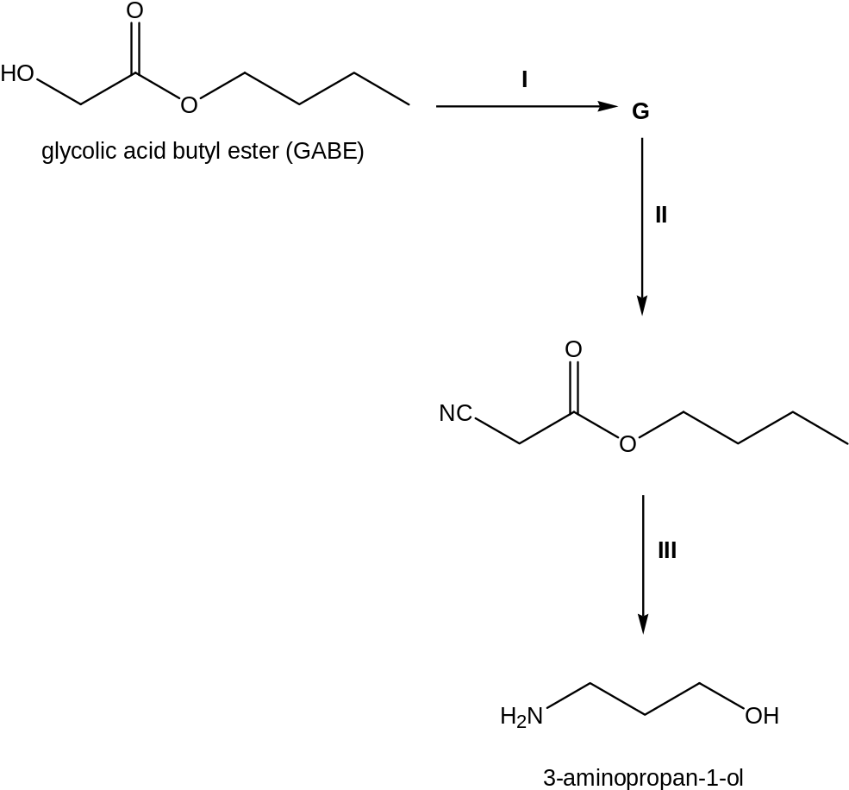
[7]

 | (c) | Glycolic acid undergoes typical oxidation reactions to give glyoxylic acid.  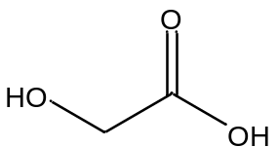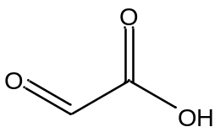  glycolic acid glyoxylic acid  Describe a chemical test that can be carried out in the laboratory to distinguish between glycolic acid and glyoxylic acid. State all observations clearly.  [2]
 | (d) | Glycolic acid reacts as a typical organic acid with organic amines to form amides and amine salts.  One such complex organic compound is compound H with the molecular formula C₈H₉NO₂. Compound H has no reaction with dilute acids but reacts readily with aqueous alkalis at room temperature. However, when compound H is warmed with dilute hydrochloric acid, compounds J and K are formed. Compound K has the formula C₆H₈NOCl and is soluble in water. Compound J reacts with sodium carbonate to release a colourless gas. Compound H also decolourises aqueous bromine to give Q, a compound with the molecular formula C₈H₇NO₂Br₂.  Identify compounds H, J, K and Q and briefly explain the reactions described.  [5]
 |  | [Total : 20]

5 | Terpenoids and terpenes form a large group of natural products and are the primary constituents of the essential oils of many plants.
 | (a) | One example of a terpenoid is anethole, found in the essential oil of star anise, among other plants.  Anethole can be synthesized from estragole, a structural isomer of anethole. Anethole has also been reported to be used in the illegal manufacture of para-methoxyamphetamine (PMA), a chemical found in “Ecstasy tablets”.
 |  |  | 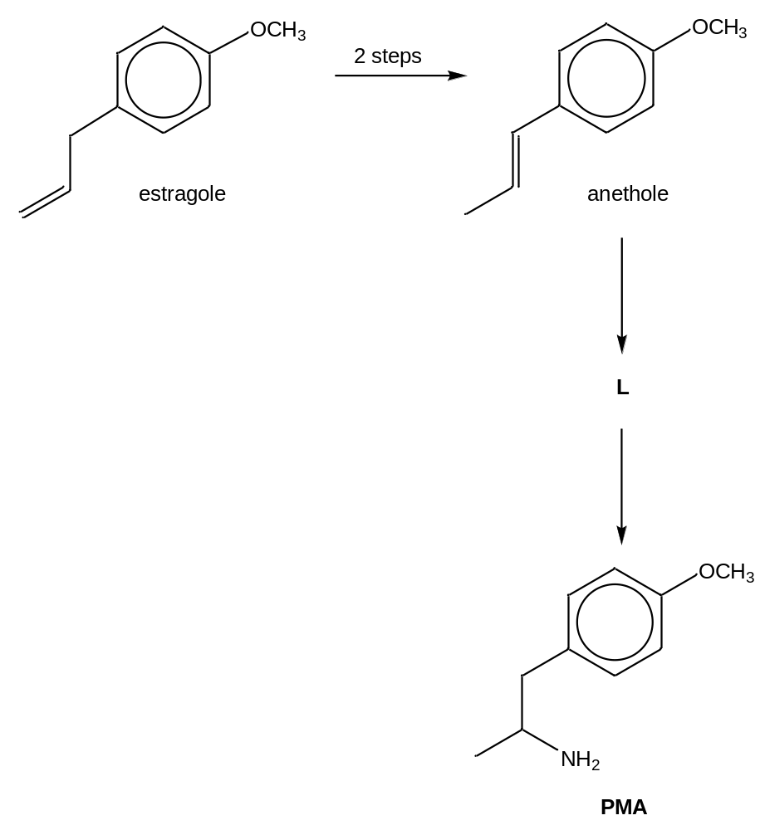
 |  | (i) | Propose a 2-step synthetic route to synthesise anethole from estragole. State the reagents and conditions clearly and draw the structural formula of the intermediates.
 |  | (ii) | Suggest a structure for L.

 |  | (iii) | In the synthesis of anethole from estragole, a mixture of anethole isomers can be formed. Suggest the type of isomerism involved.

 |  | (iv) | With reference to a(iii), predict which isomer of anethole would be the predominant one in the reaction product mixture. Explain your answer using their relative stability.
 |  |  | [7]
 | (b) | In the biosynthesis of terpenoids, two active bioprecursors are the diphosphates of 2 isomeric primary alcohols M and N, with molecular formula C₅H₁₀O. Both decolourise aqueous bromine.  Oxidation of M using hot acidified potassium manganate(VII) yielded only propanone. Treatment of N with potassium manganate(VII) under the same conditions gave a single organic compound P, C₄H₆O₃. In both cases, carbon dioxide gas was evolved. Reaction of P with alkaline aqueous iodine gave a pale yellow precipitate. When solid sodium carbonate was added to P, effervescence was observed.  Use all the above information to identify the organic compounds M, N and P. Include the following in your answers:  - Structural formula of each of the organic compounds.  - Clearly show all of the deductions that you make from the information that you have been given (balanced equations are not required).
 |  |  | [6]
 | (c) | Using relevant data from the Data Booklet, calculate the E∅_{cell} value to describe and explain each of the following phenomena related to Group VII elements. Give an equation with state symbols for each reaction that occurs.
 |  | (i) | When fluorine gas is passed through water, a gas that relights a glowing splint is produced. When bromine is passed through water, no such gas is evolved.
 |  | (ii) | When a sample of aqueous chlorine is added to aqueous iron(II) chloride followed by the addition of aqueous sodium hydroxide, a reddish brown precipitate was observed.
 |  |  | [7]
 |  |  | [Total: 20]

